goMoto 3.3 (Early 2020 – Present)
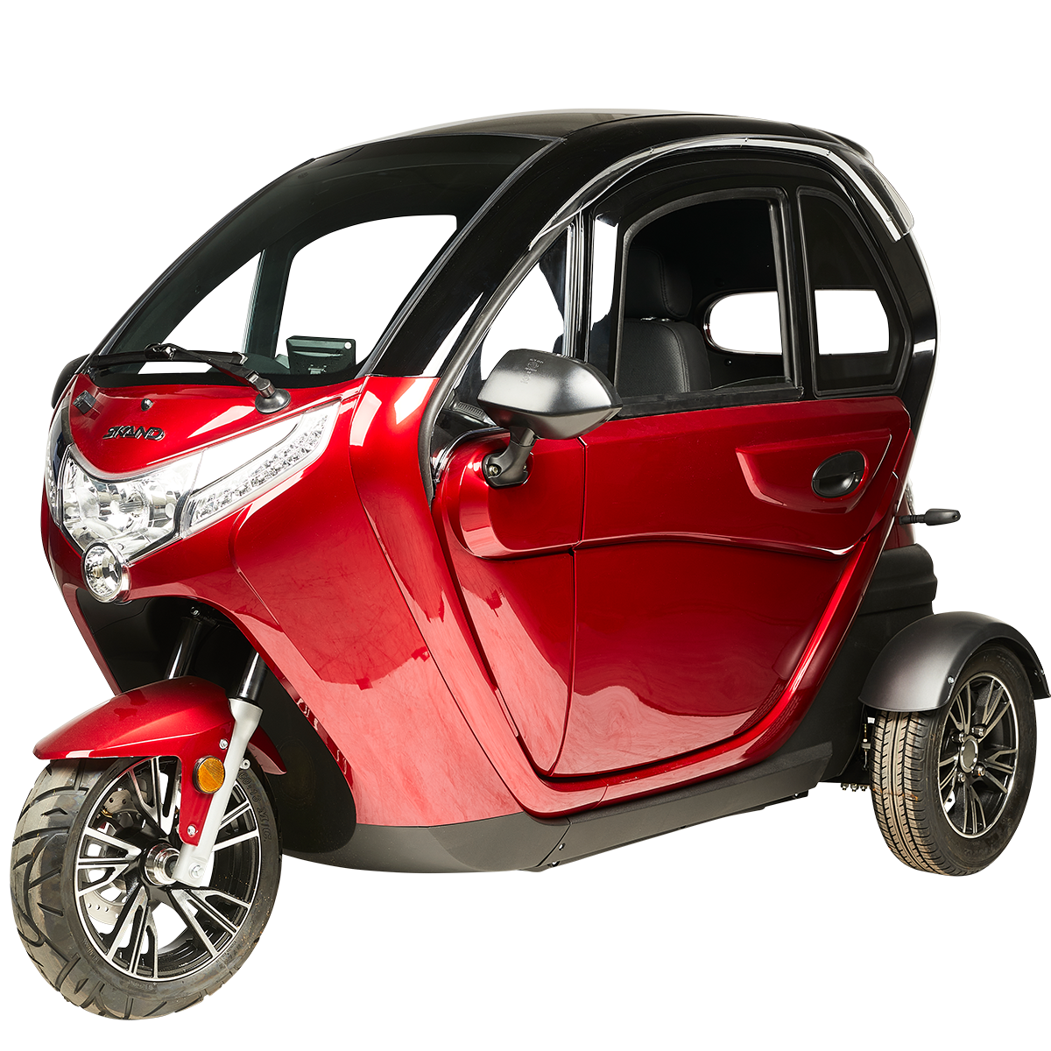
- Colours: Red and White
- Power: 1000W and 2000W models
- Top speed: 25 km/h and 45 km/h models
- 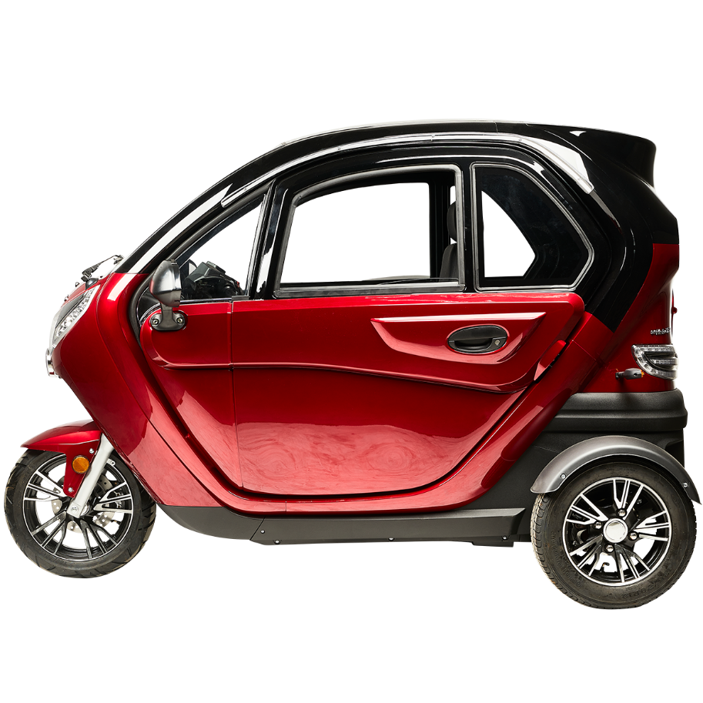
- 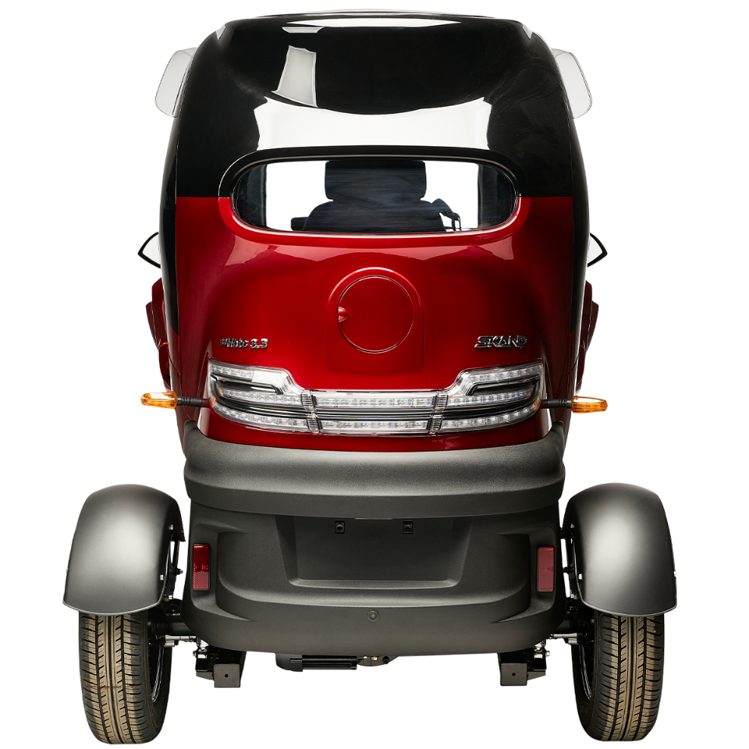
- 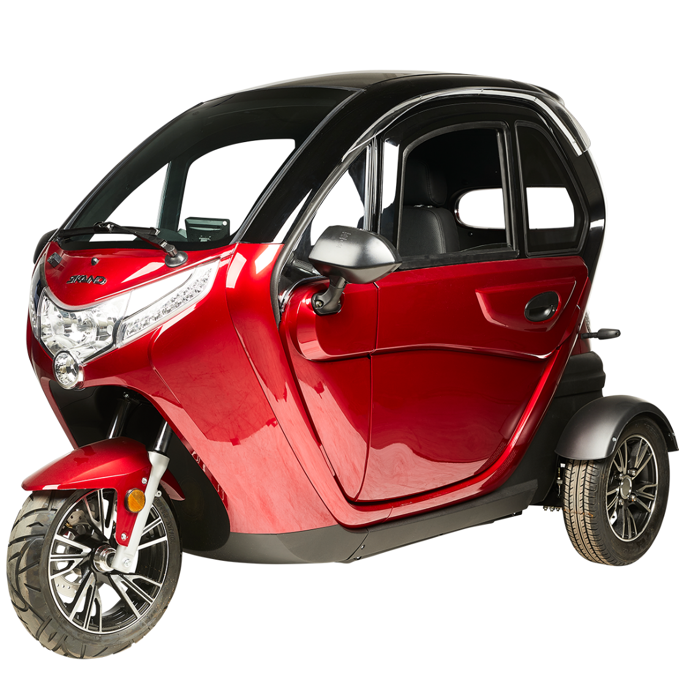
General information
60V 45Ah (5 x 12V 45Ah lead-acid)
This is new model, and the only bigger change is motor axle’s wormgear and radio. If you cannot fix the differential gear, you might need to order whole new rear axle. Difference between old and new model is the motor axle’s wormgear, old one has gear with diameter of 24mm and new one 28mm. That is also why you need matching rear axle (differential is integrated). Always measure the wormgear before ordering anything.
If you see radio with screws on top plate corners right under the windscreen, you are holding old type goMoto 3.3.
Technical specifications
Length | 2260 mm
Width | 1160 mm
Height | 1510 mm
Wheelbase | 1700 mm
Seat height | 520 mm from ground level, 320 mm from floor level
Weight (including the batteries) | 240 kg
Top speed | 25 km/h / 45 km/h
Motors | 1000W or 1500W
Brakes | Hydraulic disc brakes
Battery capacity | 2,7kWh = 60V 45Ah (5 x 12V 45Ah)
Battery type | Lead-acid VRLA
Battery pack weight | 66 kg (5 x 13,2 kg)
Range | Up to 50 km
Charging time | Up to 12 hours, depending on the initial charge level of the batteries
Maximum load | 150,5 kg
Tyre size | Front = 130/60R13 | Rear = 135/70R12
Vehicle category | L2e-P
Number of seats | 2
Seatbelt | Yes
Maximum torque of the motor | 48 N.m continuous
Maximum hill-starting ability at the  maximum load | 8% slope
Available colors | Red and white

